1MB 10MB/s 10ms

10MB 10MB/s 10ms

100MB 10MB/s 10ms

1MB 100MB/s 10ms

10MB 100MB/s 10ms

100MB 100MB/s 10ms

1MB 1GMbps 10ms

10MB 1Gbps 10ms

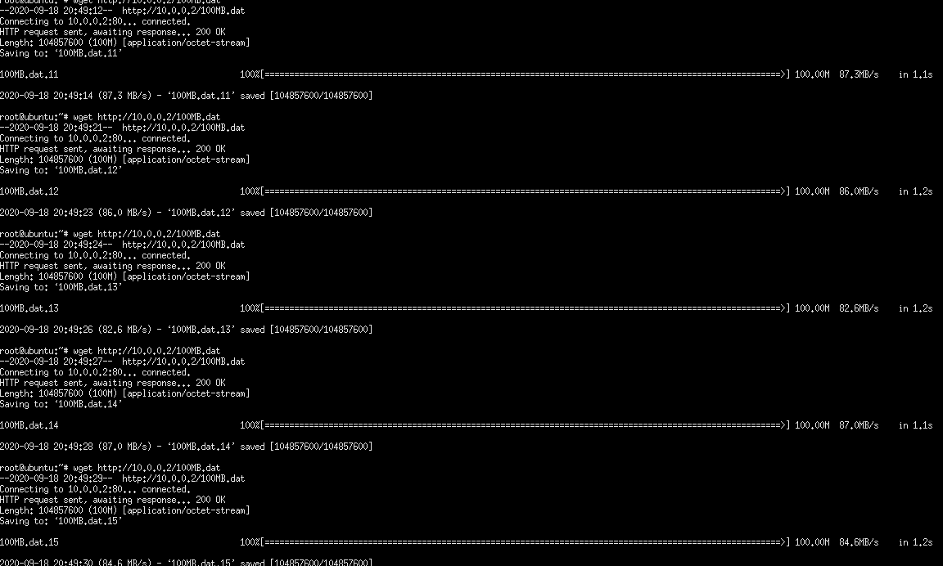

100MB 1Gbps 10ms

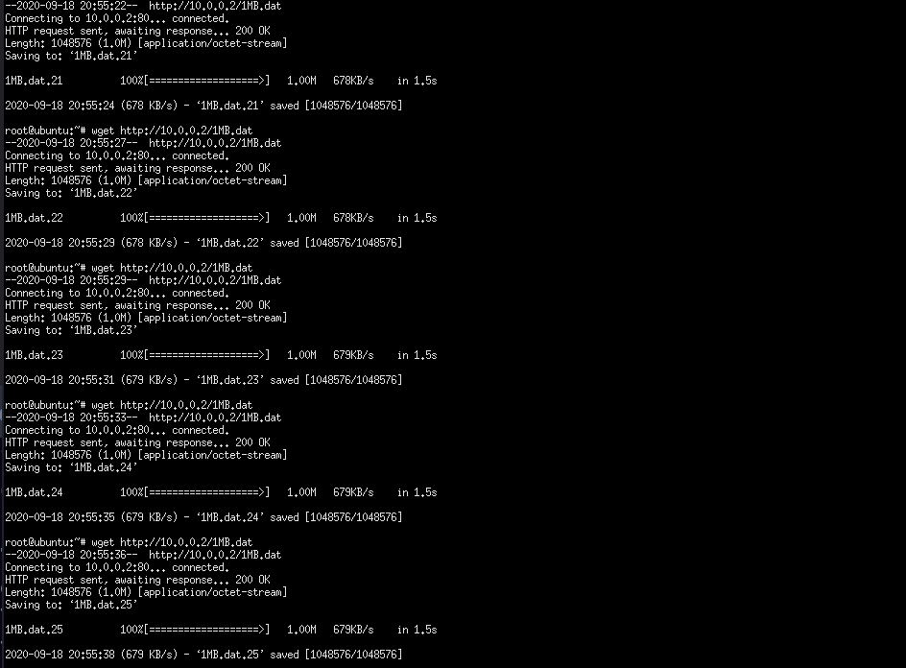

1MB 10Mbps 100ms

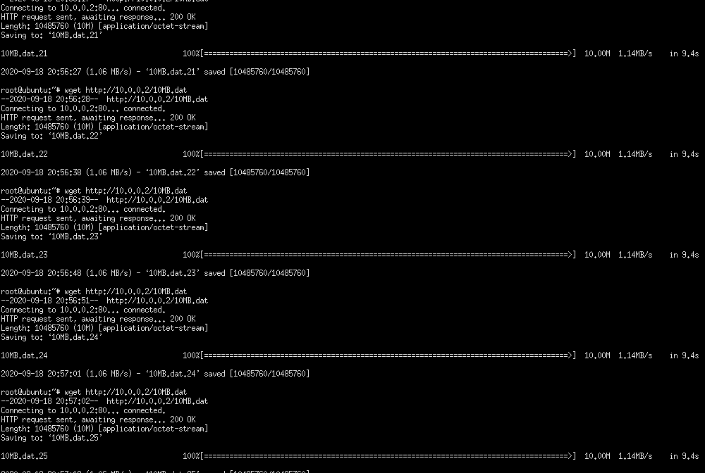

10MB 10Mbps 100ms

100MB 10Mbps 100ms

1MB 100Mbps 100ms

10MB 100Mbps 100ms

100MB 100Mbps 100ms

1MB 1000Mbps 100ms

10MB 1000Mbps 100ms

100MB 1000Mbps 100ms